**Metaheuristic Strategies for Advancing Process Management in Building Foundations Using Soil Data**

Słowa kluczowe:

1. Soil data
2. Metaheuristic methods
3. Ground interaction
4. optimization of production processes

5.construction innovations

6. system reliability

**WERSJA DŁUGA ABSTRAKTU**

Effective management of production systems in the construction industry requires a complex solution of organizational and technical problems related to the coordination of heterogeneous optimization criteria performance. The primary impediment to real estate development is the complexity of making informed management decisions during the planning and execution of construction projects. Conflicting interests among various stakeholders can lead to disruptions in production processes and potential crisis situations.

An essential stage in the construction of buildings is the foundation phase, which includes preparatory steps, earthworks, and the actual execution of the foundations. A critical aspect to consider during this phase is the geophysical data of the soil on which the structures will be built.

The aim of this article is to explore the potential for adapting metaheuristic optimization methods on step of earthworks enhance intelligent construction management technologies. Implementing this approach aims to improve decision-making processes, optimize production workflows, increase productivity, and achieve strategic objectives.

The innovativeness of the scientific hypothesis of the article lies in the development of an automated control algorithm based on metaheuristics, which broadens the application of digital information technologies across the stages of design, modeling, implementation of construction projects, and quality management of building operations. The foundation of this research is inspired by the functioning of biological systems in nature, aimed at enhancing construction production management. The approach consists of: finding criteria for optimizing the production process, clarifying the relationships between the them characteristics, determination of critical places and problem situations in the structure of these interrelationships of production, formation of algorithmic stages of metaheuristic optimization of the production process in construction, creation of an intelligent metaheuristic optimization software algorithm for manufacturing process simulation.

The result of the work on the metaheuristic approach applied during foundation construction is the creation of an algorithm containing guidelines for planning and executing foundation works, taking into account the most important geophysical parameters and principles of sustainable development.

**WERSJA KRÓTKA ABSTRAKTU**

**Metaheuristic Strategies for Advancing Process Management in Building Foundations Using Soil Data**

This article focuses on the foundation of buildings, emphasizing the importance of considering geophysical parameters. It presents the development of a metaheuristic approach to create an algorithm that provides guidelines for planning and executing foundation works. The algorithm integrates critical geophysical data and principles of sustainable development, ensuring efficient and environmentally responsible construction practices.

**LINK DO APPLIED SCIENCES**

[**https://www.mdpi.com/journal/applsci/special_issues/400593X812**](https://www.mdpi.com/journal/applsci/special_issues/400593X812)

**Prawdopodobnie w zamian za brak opłat trzeba będzie zrobić recenzje jakiegoś artykułu !!!**

**1. Introduction**

Scientific research and publications on production optimization show that the use of combinatorial optimization models and algorithms can effectively solve practical production problems in construction. Modeling of construction processes is often implemented by discrete optimization models that successfully reflect nonlinear dependencies, indivisibility of objects, and also take into account logical constraints while meeting the requirements of the technology and quality of construction processes.

In the scientific article [1], the authors propose an innovative approach to optimize construction management using metaheuristic methods and Bayesian networks. The algorithmic steps of metaheuristic optimization of the construction process were developed. The optimization procedures used for the research were based on the rules of the golden ratio [0.38; 0.62]. Confirmation of the effectiveness of the proposed scientific ideas was realized through the means of optimization modeling of Bayesian networks. This work has revealed the scientific potential of applying metaheuristics in construction optimization processes not only in production management, but also in predicting future problems.

The developer is constantly trying to make the construction project better, and uses a variety of practices and experience to do so. It is proposed that the optimal management decision is a reflection of the characteristics and functions of the forward-looking thinking of a civil engineer. The success of effective decision-making ensures the reliability of the initial data of a construction project.

It is known that the main functions of foresight are reasoning and balancing.

Reasoning refers to actions related to structures, namely synthesis (construction) and analysis (decomposition). Balancing means finding an optimal solution between two extreme cases.

To implement forward thinking, you can develop a thinking model (or calculation model) that incorporates memory and time. The forward thinking model is based on three aspects: reasoning, balancing, and the nature of memory/time. These aspects describe the essence of optimization programming using metaheuristics.

To understand what any optimal strategy looks like, we need to consider the principle of the balancing apparatus. It is known that balancing is one of the most important functions of thinking when making management decisions in construction.

Optimization by the harmonic component is the search for a balanced solution between two extreme variables [best ... worst]. The mathematical form of balancing is well represented by the golden ratio:

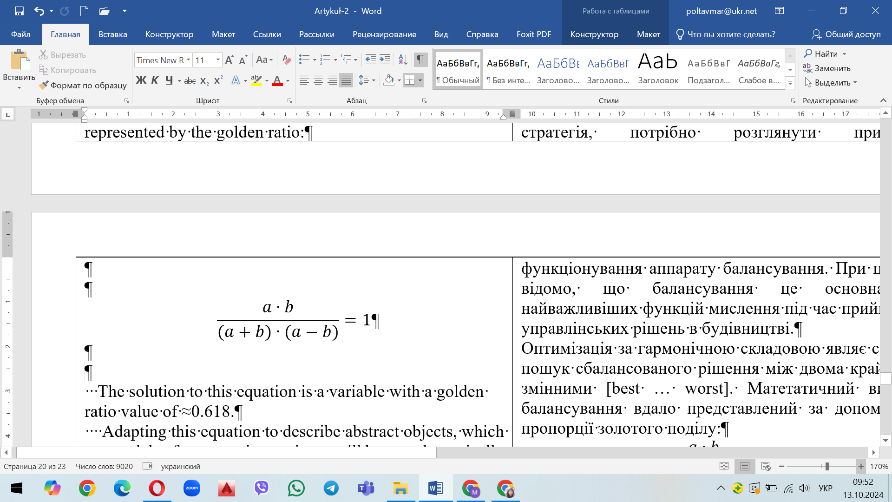

The solution to this equation is a variable with a golden ratio value of ≈0.618.

Adapting this equation to describe abstract objects, which are models of construction projects, will be a mathematically transformed expression of balancing the golden ratio, which contains the complexity function *fcomp* , the similarity function *fsim* and the difference function *fdif*. All the proposed functions form a harmonic equation for balancing the elements of the production management system. The harmonic value regulates the balance between similarity and difference.

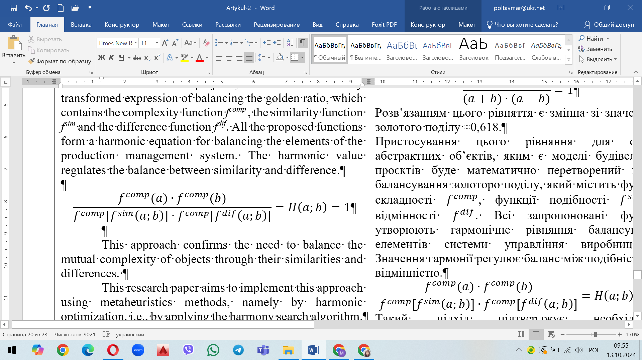

This approach confirms the need to balance the mutual complexity of objects through their similarities and differences. This research paper aims to implement this approach using metaheuristics methods, namely by harmonic optimization, i.e., by applying the harmony search algorithm.

All tasks of construction production planning focus on finding a state of the object that will meet a certain optimality criterion with efficient resource allocation. In this research direction, the development and study of metaheuristic algorithms for solving practical problems of optimizing construction production is relevant.

Metaheuristics are a powerful and extremely popular class of optimization methods that allow you to find solutions for a wide range of problems from various fields of activity, including very effective in construction production planning. The advantage of metaheuristic methods is that they make it possible to solve intractable optimization problems and operate on strategies that guide the search for solutions. Metaheuristic algorithms use a direct random search for possible solutions (optimal or close to optimal) to a scientific problem until the final criterion (the limit of the maximum number of iterations) is reached. The priority of metaheuristics is to effectively explore the search space to identify optimal (near-optimal) solutions.

Despite the fact that construction optimization tasks have their own individual characteristics of behavior when solving various scientific problems, all metaheuristic algorithms have a number of common components and function within a certain number of categories.

1) Initialization. Definition and ways to find the initial solution.

2) Functioning space. Each solution corresponds to a set of functioning spaces and the links between them.

3) Segregation of the functioning space is based on the choice condition and behavioral features.

4) Determination and evaluation of components for the implementation of the optimization process, taking into account the set of transitions between iterations.

5) Acceptance of the result. Determining the best result and giving it the status of the optimal result.

6) Stopping criterion. Stopping the algorithm based on the accepted stopping criterion.

**2. Justification of the Research Field**

Traditional design and construction of building foundations requires a focus on progressive direction of construction processes, i.e., their improvement. There is no doubt that conservative approaches to foundation construction have many years of experience in wide application in production around the world. However, in the context of the rapid development of civilization and the growth of anthropogenic requirements of mankind, ineffective results arise. Such circumstances require improvement of existing production methods.

This research article presents an approach to applying the Harmony Search Method metaheuristic optimization algorithm, which can be used to improve foundation construction.

The Harmony Search Method has been applied in the construction of .......... (the name of some construction project from which empirical data will be taken). In this research, the metaheuristic algorithm is modified to take into account the peculiarities of the processes of organizing and managing construction production.

The process of harmony search in creating harmonious music that is enjoyable and attractive to the ear is similar to the search for optimality in the process of optimizing various directions.

The harmony search algorithm (HSA) is known in science as one of the most powerful metaheuristic optimization methods inspired by musicians' ability to improvise, which involves less mathematical effort and highly accurate results.

The harmony search method imitates the process of improvisation by a performing musician. The main idea of the harmony search method is to model the process of harmony selection by a performing musician, i.e. to create pleasant music.

In the process of implementing the method, when creating music, the musician selects the right note to achieve the best harmony. Each decision of the musician, which is selected from the set of valid decisions, generates a corresponding value of the objective function in order to achieve a global extremum.

All notes that fall out of the general harmony range are replaced with more aesthetically pleasing ones.

The choice of a particular pitch can be made in the following ways according to several alternatives:

Option 1: the musician recalls a successful sound combination and plays the corresponding note;

Option 2: The musician plays the note next to the one that is stored in his or her memory;

Option 3: the musician plays a random note from all possible notes.

This process of harmonic search is formalized by the creators of the method in the form of an algorithm, where the pitch (note) corresponds to the value of a variable, the sound combination is a solution from the set of possible solutions, and the effect of the harmony sound is the value of the objective function that corresponds to the selected values of the variables.

**3.** **Implementation of Harmony Search Algorithm**

A certain number of solutions are generated on the set of valid solutions ***D*** (the space of all solutions in the world around us). For each solution (for each sound combination), the value of the objective function is calculated. All the coordinates of the solution (sound combination) and the corresponding function value are placed in a matrix (respectively by rows). This matrix is called the Harmony Memory (HM). Among all the solutions (sound combinations) contained in the memory, the worst one is selected, the one that needs to be replaced. Next, a new solution (new sound combination) is generated and compared to the worst one in the harmony memory. If it turns out that it is better in terms of the objective function, then this solution is placed in the harmony memory instead of the worst one. After the described substitution in the harmony memory (i.e., after “improving” the worst option), the worst solution is found for the next comparison. The search process ends when the maximum number of iterations is reached [2, 3].

The coordinates of the new solution are generated independently of each other. To obtain the value of the next coordinate , the corresponding coordinate of the solution is chosen with a certain probability, which is randomly selected from the harmony memory. Otherwise, a random value is selected in the interval […], which determines the permissible values of this coordinate.

If the value of the solution coordinate is taken from the harmonic memory, then with a given probability it is corrected by a small increment (addition or subtraction). If no correction is performed, the uncorrected value of the coordinate is used.

Table-Comparison table of optimization parameters comparison of optimization parameters

| Harmony search method | Mathematical value | Optimization of construction |
| --- | --- | --- |
| single musical note |  | variable in the decision vector |
| sound combination, individual harmony | *↔ H* | management decision  (solution vector) |
| melody, the effect of the sound | *f* | objective function of the decision vector |
| memory of harmony | HM | knowledge and experience of the decision maker |

**Step 1. Initialization of the algorithm. Introduction of the optimization program and parameters for the algorithm.**

*HSA – (harmony search algorithm)*

In the HS harmony search algorithm, each possible control decision is called a "harmony", and each decision variable corresponds to a musical note.

*HM* – (harmony memory) is a memory area where all decision vectors (sets of decision variables) are stored.

The harmony memory size (HMS) - the number of solution vectors in the harmony memory.

For this scientific study (to optimize any construction process), it is possible to enter any number of solutions to form a harmony memory (for example, set 10 solutions).

Harmony memory size (*hms)* - the size of the (*HM*) harmony memory/

The *hms* parameter regulates the number of solutions that will be used in the formation of subsequent generations. The larger this parameter is, the greater the range of valid solutions will be and the greater the probability of finding an extremum of the function, the area of attraction of which is small.

HMCR (harmony memory considering rate) - the frequency of selecting values from the harmony memory. *Hmcr* is a parameter of the harmonic algorithm and means the speed of selecting the values of the solution variables from the memory for the new solution *xnew*.

This parameter is utilized while decision is made to choose new variables from the (HM) or to assign new arbitrary values.

*PAR* (*The pitch adjusting rate).*

The PAR functionally increases with iterations and is used to resolve the adjustment of some solution variables selected from the harmony memory. The implementation of the harmonic search algorithm (IHSA) expects to determine the minimum and maximum PAR values for this function.

The parameter par determines how often the worst solution will be replaced by a modified solution in relation to the solution selected from the harmony memory. If the parameter value is small, then the solution from the harmony memory will be selected more often instead of the worst solution without modification.

BW - *(The Bandwidth function)*

This function defines the range of adjustments that occur to variables in each iteration. For this function, you must enter a set of minimum and maximum bandwidth values (BWmin and BWmax). The value of this function decreases from BWmax in the first iteration to BWmin in the last iteration.

**Step 2. Formation of the initial set of solutions.**

On the set of valid solutions, generate the size of the harmony memory (HM) hms (i.e., the number of all solutions that will be used in the calculation)

The harmony memory is filled with randomly generated solutions (decision vectors). The scientific hypothesis of this study involves the concept of filling the harmony memory based on the professional knowledge, skills and production experience of the developer (managerial decision maker).

Let's assume that the goal of optimization is to minimize/maximize an objective function (*f*) depending on the number of decision variables *d*.

*Min (or) Max* →  *f →*

Find the corresponding solutions of the objective functions for each solution in the harmony memory (HM):

Create the structure of the HM Harmony memory (Table 1). The harmony memory table is filled with solution vectors. The number of these solution vectors is denoted by the letter N, which is equal to the size of the harmony memory.

Each vector is composed of the variables

Table - Structure of the harmony memory

| **1** | **2** | **3** | **4** | **5** | ***6*** | ***7*** |
| --- | --- | --- | --- | --- | --- | --- |
|  |  |  | **…** |  | ***f*** | Harmonies |
|  |  |  | … |  |  | (H*1*) |
|  |  |  | … |  |  | (H*2*) |
|  |  |  | … |  |  |  |
|  |  |  | … |  |  |  |
|  |  |  | … |  |  | *(HN*) |

Table shows this information.

A particular harmony N (Harmony (H1)) can be represented by a vector of the following form:

.

Initialize the harmony memory. This value is calculated by entering the variables of the harmony solution nr1 into the objective function f. Use equation :.

Where: *i*=1, 2, 3, …, *hms*; *j*=1, 2, 3, …, *n*

where is the lower bound of the new variable of the corresponding decision vector

is the upper bound of the new variable of the corresponding decision vector

is a random number with a uniform distribution in the range [0 ... 1].

Save these values according to the objective functions and form a harmonic memory matrix (*HM*). Create a mathematical visualization of the harmonic memory:.

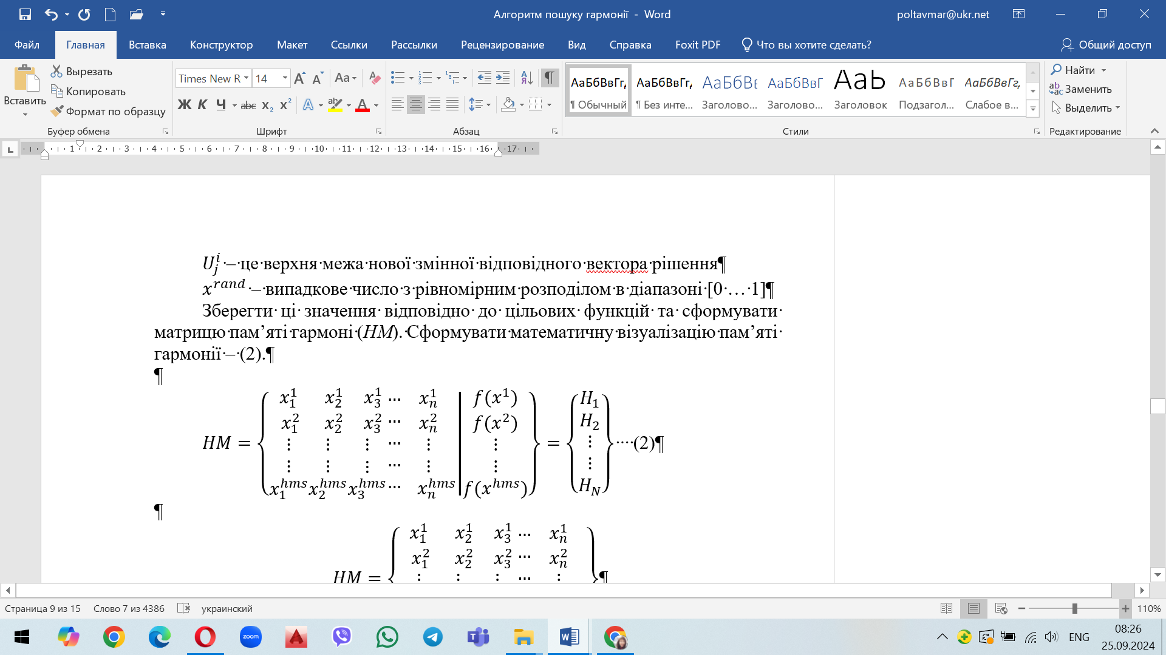

**Step 3. Generating a new solution vector, improvising a new harmony.**

Generate a new harmony using all existing information from the harmony memory. To generate a new variable for a new solution vector , the “improvisation” procedure is performed, the stages and mechanisms of which are described below. This procedure is performed for all variables of the new solution and continues until a new harmony is obtained.

This step of the algorithm is called “improvising a new harmony”, i.e. generating a new solution vector

Generate a new solution vector :

For all the variables of the new solution vector (i=1,2,3,....,*hms*; j=1,2,3,...,*n*), perform the following steps described below.

At this stage, the vector of a new harmony (new solution) is improvised based on three mechanisms:

1) the mechanism of considering the harmony memory;

2) random selection mechanism;

3) a mechanism for adjusting the pitch (variable step).

Mechanisms nr1 and nr2 use the methods of generating a new solution based on the frequency of selecting values from the harmony memory - *hmcr*.

Mechanism nr3 uses the method of generating a new solution using the pitch control speed *par*.

**Generation mechanism** **- 3.1. Mechanism for considering the harmony memory. Improvisation of the *hmcr-*type**

Generate a new variable in the decision vector based on the frequency of selecting values from the harmony memory *hmcr*.

Generate a new variable with probability *hmcr* using the harmonic memory (*HM)*.

In this case, the selection of a new value of the variable of the decision vector is performed with probability *hmcr*, which is defined as the frequency of selecting one value from the previously stored values in the harmony memory (*HM*).

If the random number () is less than or equal to the frequency of selecting values from the harmony memory (*hmcr*):

where the first variable of the new solution vector (i.e., the new harmony) is randomly selected from the variables already contained in the harmony memory (*HM*).

For example, choose a random number of value m, where 1≤*m≤n*. Then, the first variable in the solution vector is selected by the corresponding value m of the harmony variable from the harmony memory (*HM*) according (Fig 1 ):.

де

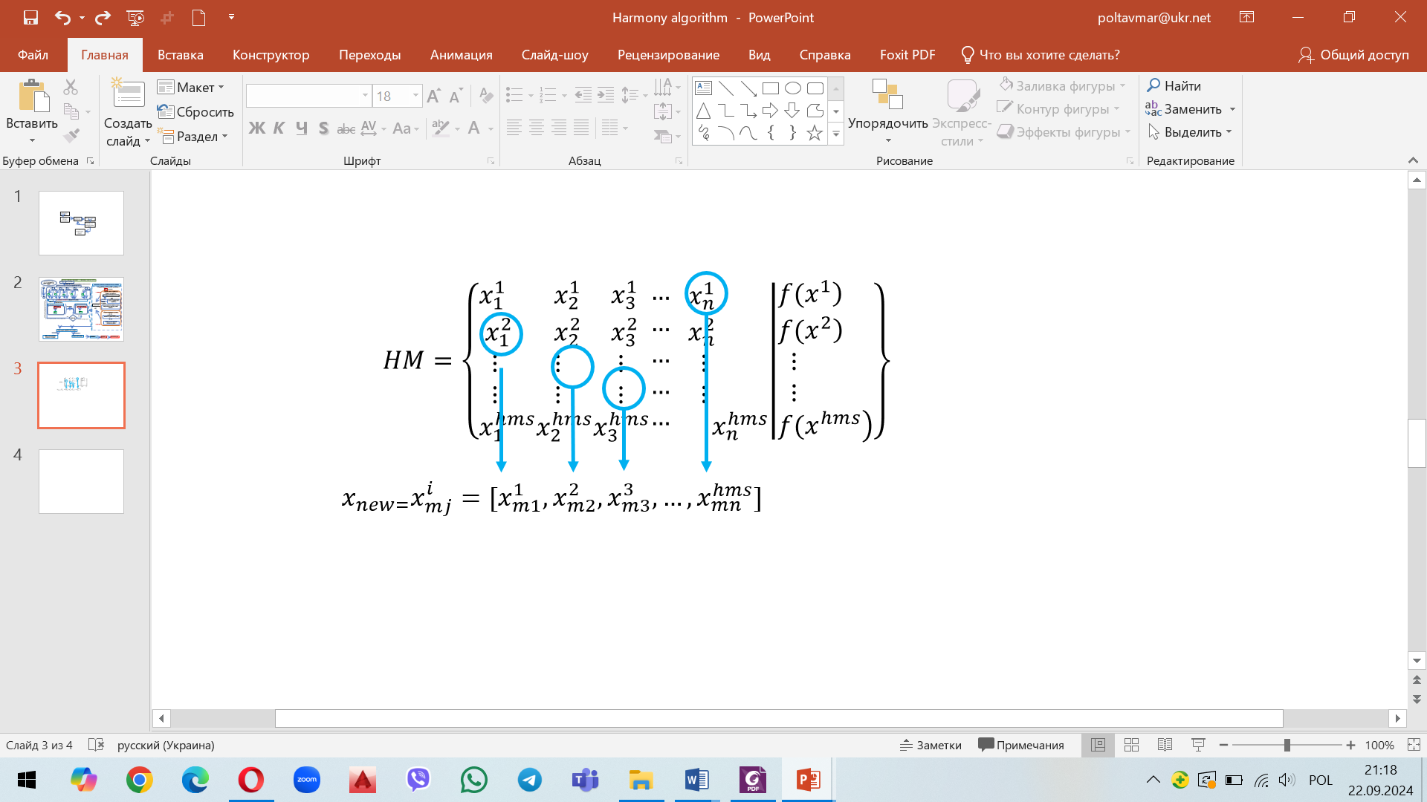

Fig.1 - Visualisation generation mechanism mechanism for considering the harmony memory

**Generation mechanism 3.2. Random selection mechanism.**

Generate a random variable in the decision vector with reference to the frequency of selecting values from the harmony memory *hmcr*.

Get the value of a random (random) number (random, random number) based on the indicator *hmcr* (frequency of selecting values from the harmony memory). Set that *hmcr* ranges from 0 to 1.

Generate a random number with a uniform distribution in the range [0 ... 1].

Perform a random selection of a new variable with probability (1- *hmcr*).

(1- *hmcr*) is the rate of random selection of one random (random) value from the possible range of values of all variables of the decision vector [*min ... max*]:

[*min … max*] = […]

In this case, the choice of a new value of the variable of the decision vector is performed with probability (*1-hmcr*), while the range of the new variable is on the range segment […].

If the random number () is greater than the frequency of selecting values from the harmony memory (*hmcr*), then condition (4) is met:

then the new variable () of the new solution vector () (i.e., the new harmony) is generated randomly according to formula:

where is the lower bound of the new variable of the corresponding decision vector

is the upper bound of the new variable of the corresponding decision vector

- a random number with a uniform distribution in the range [0...1].

Or choose a random number from the valid range of values with the number :

Then calculate it:

where is a uniformly distributed number from 0 to 1;

- procedure for finding the integer part of the number;

*m* - the ordinal number of the random number .

**Generation mechanism 3.3 Adjusting the pitch**

Generation of a random variable in the decision vector using the pitch control speed (value change step) , pitch adjusting rate *- par*

The obtained random variables in the decision vector by mechanisms 3.1 and 3.2 with the focus on the *hmcr* indicator are further investigated.

At this stage, each variable for a new solution is adjusted to the probability assigned to that variable.

In HS, there is a parameter named pitch adjusting rate (*PAR*) which varies between 0 and 1.

It is necessary to determine whether this randomly selected variable in the new decision vector requires pitch adjustment or not. This pitch check is performed using the parameter *par* (pitch adjustment rate).

With gradual iterations, *par* changes linearly from low to high values.

Small PAR values result in a weak pitch control mechanism, and large PAR values result in a strong pitch control mechanism.

Small PAR values increase the number of iterations, but are also important in the initial iterations to prevent the algorithm from getting into a loop state of local optima.

To move away from local optima, HS uses a pitch adjustment mechanism, whereby the improvised note (new variable) can be shifted to a neighboring value in relation to the possible range.

Generating high values of 𝐵W during the first iterations helps the algorithm to estimate higher distances.

This, in turn, expands the algorithm's search capabilities. As the number of iterations increases, the system checks the closest neighborhoods (distances from the newly obtained and assigned variables) and further optimizes their results.

To perform the pitch adjustment mechanism, after step 3.1, a random number () is generated with a uniform distribution from the range [0 ... 1] and compared to the pitch adjustment value (par).

UA: If is less than or equal to the pitch tuning parameter (par), then the improvised note (random variable for the solution vector) should be shifted to the neighboring value using:.

*bw* is a bandwidth parameter used to control the local search around the selected decision variable in a new vector in the search range [-*bw*; +*bw*], the bandwidth (bandwidth) function to generate a new solution.

- random number from 0 to 1 with uniform distribution;

(-0.5) is an indicator that generates a random number in the range [-0.5...0.5]. This indicator is used to randomly choose the direction of improvisation, that is, to guide the researcher in which direction to direct the new value of the new decision variable - to increase or to decrease it;

is the lower limit of the new variable of the corresponding solution vector;

is the upper limit of the new variable of the corresponding solution vector.

- an indicator used to control the scale of the variables of the new solution, since in the optimization problem the scale of the variables of the new solution can vary significantly in different dimensions.

Otherwise, if the generated random number is greater than the pitch adjustment parameter (*par*), i.e. if condition is satisfied, then the improvised new variable (note) is not adjusted:

**Step 4.** **Harmony memory updating**

At the beginning of this step of the algorithm, we have the calculated value of the objective function of the new possible harmony (*HNEW*) and the new solution vector ().

If the newly generated solution vector () is better than any of the already stored solution vectors () of the new harmony (*HNEW*) in the harmony memory (*HM*), i.e., it has a better value of the objective function , it will replace the old stored vector in the harmony memory (*HM*).

This also means that the new *HNEW* harmony will replace the old *HWORST*. harmony.

If, on the contrary, the value of the new solution () is not better (i.e., worse) than the worst solution (), then no replacement is made. In this case, the algorithm proceeds to the next cycle (iteration between steps 3 and 4) without any replacement.

**Step 5. Evaluation of the termination rule (Stopping Criterion)**

Evaluate the stopping criterion and check the condition for stopping the harmonic optimization (*HS*) algorithm.

The main regulator of stopping the harmonic optimization algorithm (*HS*) is the achievement of a given number of iterations *Kmax* - the algorithm stopping criterion.

When this criterion is met, the algorithm stops, and we proceed to step 6. Otherwise, steps 3 and 4 are repeated until the stopping criterion is met.

Checking the conditions for terminating the search process using the (HS) algorithm:

if *k<Kmax-1*, determine *k=k+1* and go to step 3;

if *k=Kmax-1*, the algorithm is terminated.

**Step 6. Final results of the algorithm**

At this step, the best harmony stored in the Harmony Memory (*HM*) is set as the optimal solution to the scientific problem under study.

Find among the newly generated solutions in the harmony memory the one with the best value of the objective function . Establish that:

The figure 2 shows a detailed flowchart of HSA implementation to optimize the construction process.

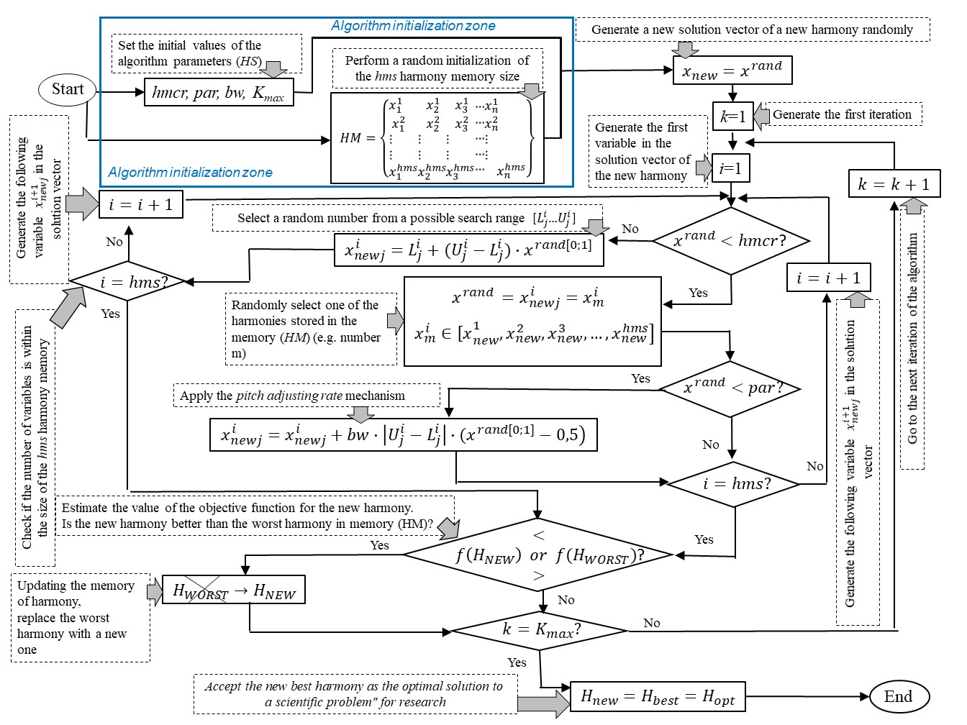

Figure 2 - Flowchart of HSA implementation to optimize the construction process (source own based on [2,3])

**4. Modification of the harmony search algorithm using the system management model.**

This research proposes an innovative way to modify the harmony search algorithm (HSA). It is proposed to apply a specific methodology at the initialization stage of the algorithm to form the initial harmony memory using the model of system control and systemology.

The essence of this methodology is to represent the initial harmony memory of the algorithm in the form of a functional system of external and internal construction factors. The authors propose to use a special model of systematic management, which is based on the general principles of systemology. This methodology of the systematic approach allows achieving the ultimate functional goal as soon as possible - the creation of an interdependent purposeful set of elements of the memory system that mutually contribute to the achievement of a given useful result (harmonization of the production system), which is accepted by the main system-forming factor at the stage of initialization of the harmony search algorithm.

In this scientific study, the harmony memory is a complex system consisting of interconnected elements and interrelationships between them. In the context of harmonization of system management and the use of promising strategies, the methodology of technological reliability of the production system is also used.

The reliability of a production system is a complex property of the production system to function at a satisfactory level within a given time period, with the acquisition of quantitative time characteristics, such as reliability, functionality, reliability, durability, stability, survivability, safety, etc.

Determination of technological reliability in the assessment of the result implies, if necessary, structural reorganization of the system and functional replacement of some elements (unreliable, failed) with other elements that previously performed other functions to ensure a given result.

This approach obliges the developer (decision maker) to adhere to a clear structural scheme of harmony memory with all the attributes of system engineering with a certain composition of elements, connections and empirical data. The realization of the research innovation is reflected through the list of complete control functions, system behavior of elements and transformations between information modules of the system in the process of optimization.

The aim is to determine the reliability of the initial harmony memory (HM) at the initialization stage of the algorithm (HSA) using the principles of system control. The indicator of the technological reliability of the system of elements of the initial harmony memory (HM) at the initialization stage will reduce the number of algorithmic iterations and speed up the optimal decision-making in construction.

The authors of the study propose that the reliability of the algorithm initialization stage is based on the system-forming factors of the construction environment (atmospheric phenomena, working conditions, biological factors, functional barriers) and the professional responsibility of the developer (professional knowledge, specialized standards, professional skills, professional experience, professional competencies, innovation, self-control, endurance) (fig.3).

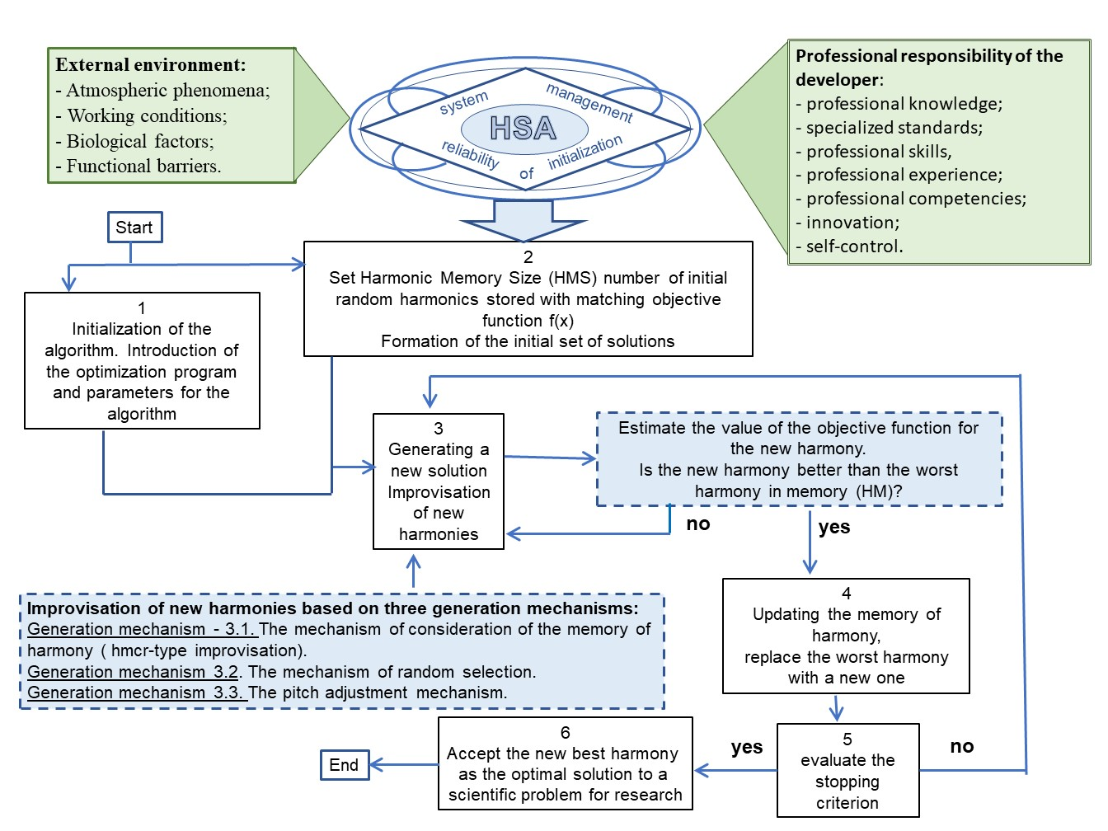

Figure 3 - Modification of the harmony search algorithm using the system management model

The system-forming factors are united by certain functions into three main groups: information modules of management, actions of the management subject, and management tasks.

The group of factors of the information module of management contains indicators of the information state of a separate variable of the decision vector xij. The information state changes the measure (PAR) of a separate variable of the decision vector (a separate element of the harmony memory system), which leads to a new material content of this element.

To introduce seven information modules into the model of systematic control of algorithm initialization (HSA):

1) the first information module (ψ1) - assessment of the state of management of the object;

2) the second information module (ψ2) - determination of the subject's own state of management;

3) the third information module (ψ3) - determination of the state of neighboring objects with which interaction is performed;

4) the fourth information module (ψ4) is the state of the environment in which the system elements interact;

5) the fifth information module (ψ5) - the state of the structure that carries out management (management entity);

6) the sixth information module (ψ6) - instructions and restrictions from higher management structures;

7) the seventh information module (ψ7) - distinction-methodology (awareness of the system management process through the combination of all seven information modules).

Management functions ensure the circulation of information and information transformation in the management process and also reflect the sequence of actions of the management entity:

1) action one (X1) - recognition of the environment factor, i.e. the factor that affects the system with which the intelligence is faced;

2) action two (X2) - formation of a recognition stereotype, i.e. recognition of the environment factor for the future;

3) action three (X3) - forming a vector of goals for each environmental factor and adding the time vector to the overall vector;

4) action four (X4) - formation of the target function (concept), management based on the solution of the problem of sustainability by foresight;

5) the fifth action (X5) is the organization of a management structure that manages and carries the target management function;

6) the sixth action (X6) - control, monitoring of the system structure in the process of management;

7) the seventh action (X7) - maintaining performance or liquidation - maintaining the performance of the structure in the management process or its liquidation (if necessary).

Full management functions can be realized only in an intelligent management scheme, which implies the creativity of the management system, the presence of the manager's intelligence, who is obliged to solve the following tasks:

1) task one (χ1) - identification of environmental factors that affect the production system (this cannot be done without a creative approach);

2) task two (χ2) - formation of goal vectors (this is also a creative process);

3) task three (χ3) - formation of new management concepts (how to do all this, what new tools to use, what promising forces?)

4) task four (χ4) - improvement of the methodology of forecasting and correction in solving sustainability problems by predictability according to the “predictor-corrector” scheme;

5) task five (χ5) - the ability of the control system to independently produce a new information module based on the control systemology.

To increase the reliability of initialization of the HSA algorithm using a system-forming model that reflects the structure and logic of complex interaction between the elements of the HM harmony memory.

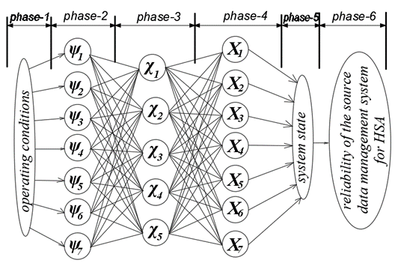

Figure 1 - A system-forming model (system-management) to ensure the reliability of HSA initialization

The model in Figure 1 reflects the interconnection of information modules, complete functions of production system management and combines the states of the system's perspective development through the following transformation phases: the first phase is the phase of system environmental conditions (initial data); the second phase is the phase of information capabilities of functional flows; the third phase is the phase of an intelligent control scheme; the fourth phase is the phase of implementation of functional processes of system management; the fifth phase is the phase of system state formation; the sixth phase is the phase of targeted possibilities.

**Conclusions**

The article under consideration continues the scientific direction of the authors' research using strategies of metaheuristic algorithms (the golden section method and the Bayesian method) to optimize various production processes in construction.

This study covers the development of foundation construction innovations using a harmonic search algorithm that successfully uses the concept of memory (experience and competence of the builder) to make optimal design and engineering decisions. The paper shows the effectiveness of applying the harmony search algorithm in engineering problems of construction, taking into account the technological features of construction processes, which are an example of stochastic systems.

The result of the scientific work is an innovative way to modify the harmony search algorithm (HSA) using the model of system management and systemology. The beneficial effect of this innovation will ensure the reliability of the initial data that form the harmony memory at the initialization stage of the HSA algorithm, which speeds up the process of optimizing a construction project.

With the help of metaheuristic strategies, it is possible to overcome the complexity of making optimal engineering and technical decisions and increase the use of innovations in construction.

**References**

**1.** Anna Jakubczyk-Gałczyńska, Agata Siemaszko, Maryna Poltavets. Optimizing Construction Engineering Management Using Metaheuristic Methods and Bayesian Networks . *Applied sciences.*, 2024, 14 (Issue 11), 4871. DOI:<https://doi.org/10.3390/app14114871>

**2.** Alireza Askarzadeh Esmat Rashedi. Harmony Search Algorithm: Basic Concepts and  
 Engineering Applications [*Recent Developments in Intelligent Nature-Inspired Computing*](https://www.igi-global.com/gateway/book/173681) Chapter 1,· March 2017. 36 p.DOI: 10.4018/978-1-5225-2322-2.ch001

3. [Geem](https://link.springer.com/book/10.1007/978-3-642-00185-7#author-1-0) Z.W. Music-Inspired Harmony Search Algorithm**.** Theory and Applications. Springer, 2009, 216 p.

**—-------------------------------------------------------------------------------------------------------------**

**Bedroom building of a hotel for summer vacation on the coast of the Sea of Azov in Genichesk, Ukraine.**

The existing building for short-term accommodation is a separate, brick, two-story building with an attic floor of a complex shape in plan with dimensions in axes of 30.9 x 18.3 m. The height of the premises is 2.7 m. The structural scheme of the building is load-bearing longitudinal and transverse brick walls and prefabricated reinforced concrete floors and roofs. Spatial rigidity is ensured by the joint work of rigid discs of floors and brick walls.

Building structures:

- foundations – strip, concrete;

- external walls – load-bearing, made of sand-lime brick

on cement-sand mortar, 510 mm thick;

- internal walls – brick, 380 mm thick;

- interior partitions – brick, 120 mm thick;

- interfloor ceiling – reinforced concrete hollow-core slabs;

- lintels above window and door openings – reinforced concrete;

- flights of stairs and landings – prefabricated reinforced concrete;

- roof – pitched, metal tiles on wooden elements

roofs with organized drainage.

Newly constructed structures:

- foundations for platform posts – free-standing with plan dimensions of 0.9x0.9 m;

- platform structure: platform posts and beams are made of metal structures on which a monolithic reinforced concrete slab is installed;

- internal and external stairs are made of metal structures with reinforced concrete steps.

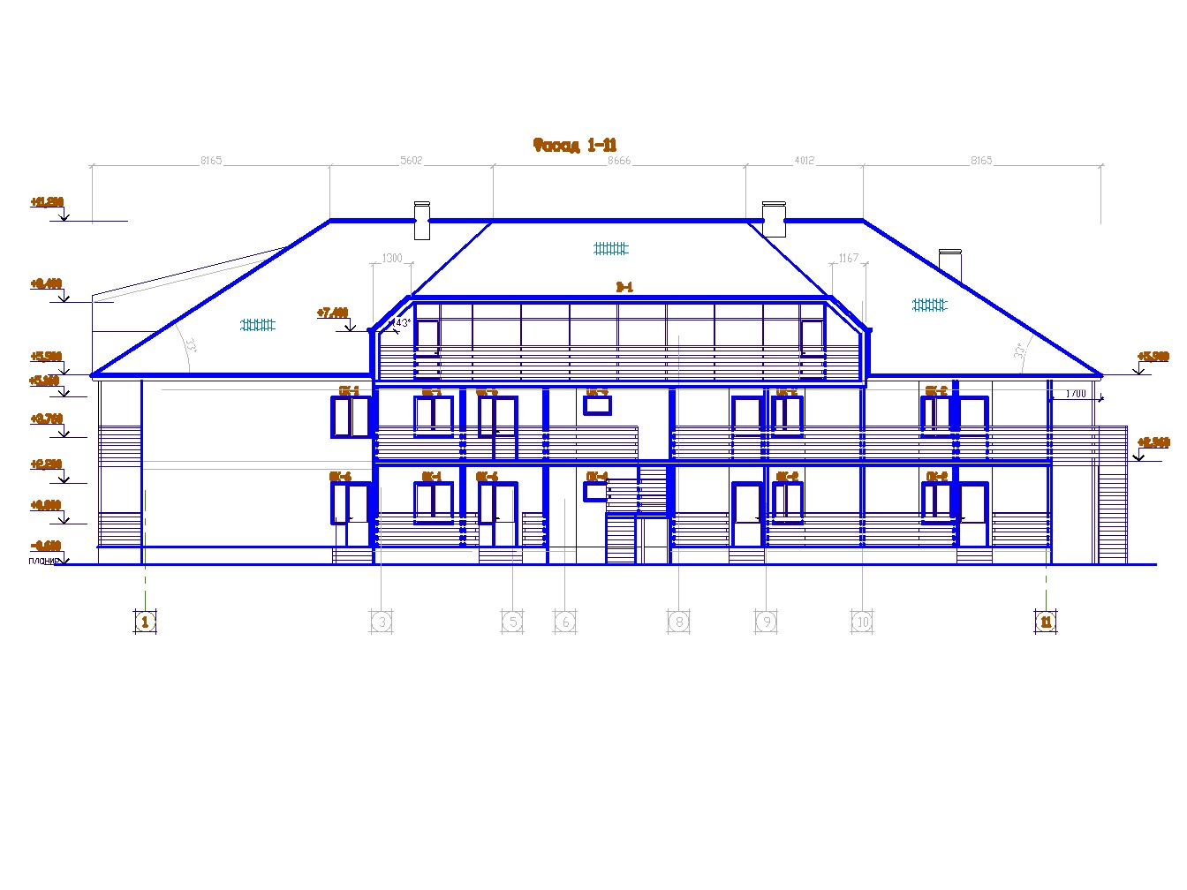

**Figure - Building facade**

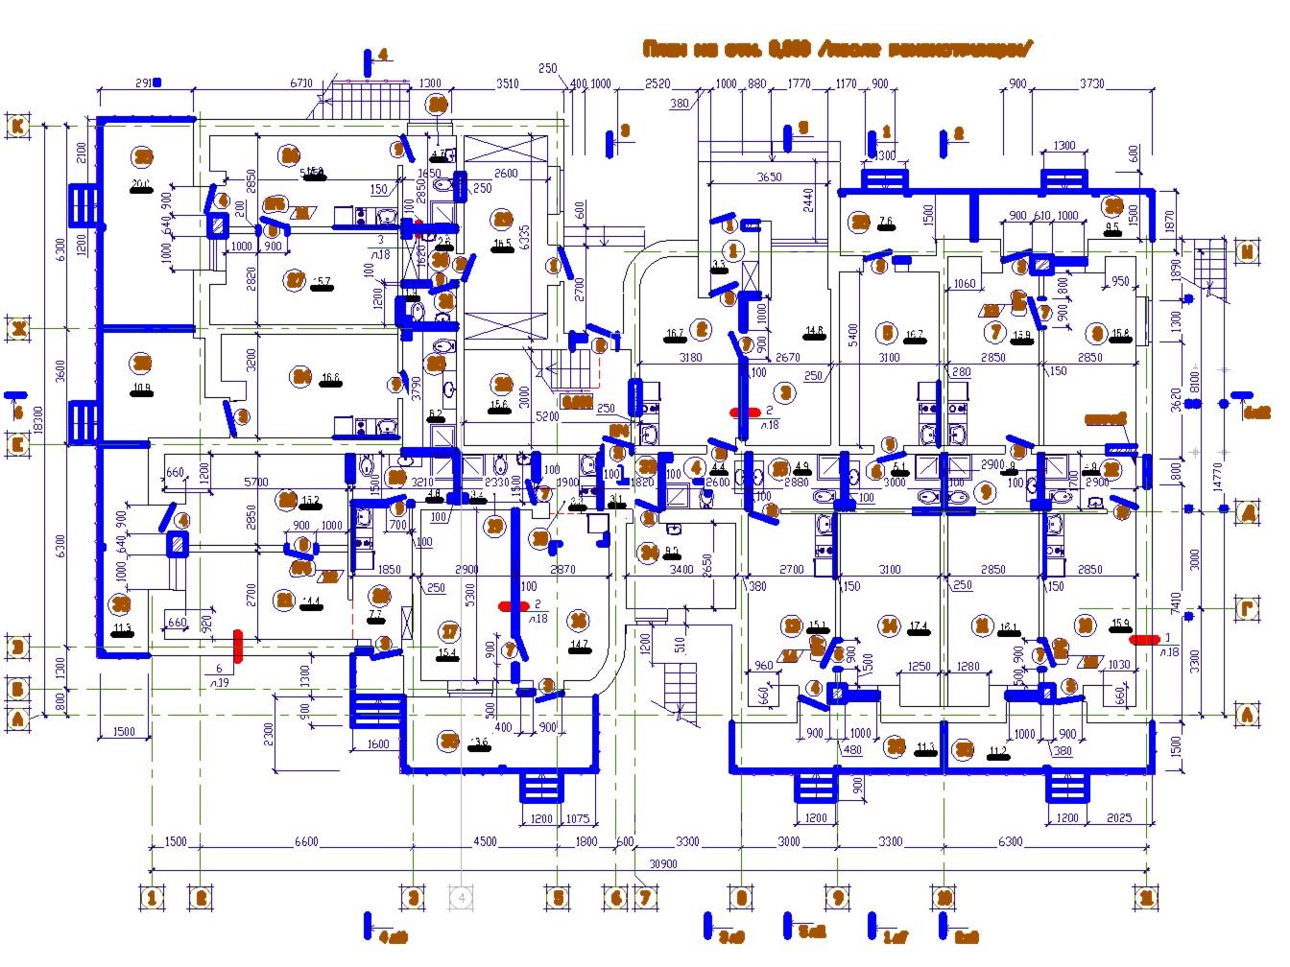

**Figure - Plan of the hotel building**

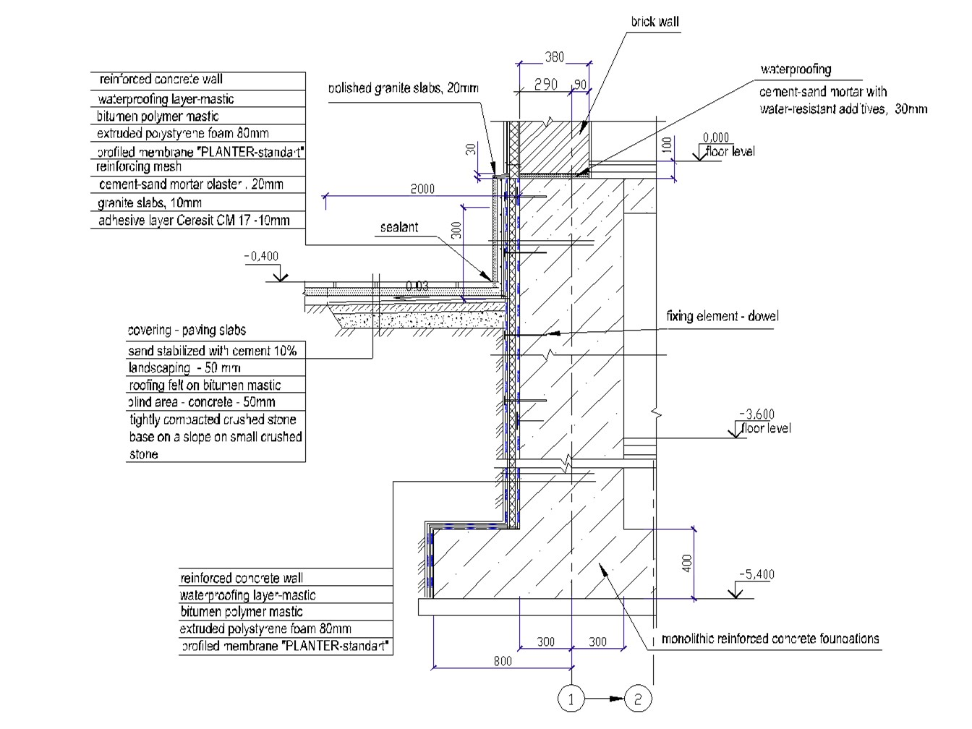

**Figure - Konstrukcja fundamentu**